**EXPERIMENT-1.1**

|  |  |
| --- | --- |
| **Student Name**: SANSKAR AGRAWAL | **UID:** 20BCS5914 |
| **Branch**: CSE | **Section/Group:** 806/B |
| **Semester**: 5th | **Date of Performance**: 24/08/2022 |
| **Subject Name**: PBLJ Lab | **Subject Code:** 20CSP-321 |

1. **Aim/Overview of the practical:**

To develop a java application, which accepts employee id from the command prompt and displays the following details as output: Emp No Emp Name Department Designation and Salary.

1. **Task to be done/ Which logistics used:**

Eclipse IDE (Java)

1. **Code:**

**package** pblj_lab;

**import** java.util.Scanner;

**public** **class** employee

{

**public** **static** **void** main(String[] args) {

**int** DA=-1;

Scanner obj=**new** Scanner(System.***in***);

**int**[] Empno={1001,1002,1003,1004,1005,1006,1007};

String[] Empname={"Ashish","Sushma", "Rahul","Chahat","Ranjan","Suman","Tanmay"};

String []Joindate={"01/04/2009","23/08/2012","12/11/2008","12/06/2006"};

**char**[] DesigCode={'e','c','k','r','m','e','c'};

String[] Dept={"R&D","PM","Acc","FrontDesk","Engg","Manufacturing","PM"};

**int**[] Basic={20000,30000,10000,12000,50000,23000,29000};

**int**[] HRA={8000,12000,8000,6000,20000,9000,12000};

**int**[] IT={3000,9000,1000,2000,20000,4400,10000};

System.***out***.println("SANSKAR AGRAWAL UID-20BCS5914 ");

System.***out***.println("Enter the employee id ");

**int** index=-1;

**int** n=obj.nextInt();

**for**(**int** i=0;i<7;i++)

{

**if**(Empno[i]==n)

{

index=i;

}

}

**if**(index==-1)

{

System.***out***.println("Employee not found");

**return** ;

}

**switch**(DesigCode[index]) {

**case** 'e':

DA=20000;

**break**;

**case** 'c':

DA=32000;

**break**;

**case** 'k':

DA=12000;

**break**;

**case** 'r':

DA=15000;

**break**;

**case** 'm':

DA=40000;

**break**;

**default**:

System.***out***.println("Employee not found");

}

System.***out***.println("Emp No. Emp Name Department Design Salary ");

System.***out***.println(Empno[index]+"\t"+Empname[index]+"\t\t"+Dept[index]+"\t\t "+DesigCode[index]+"\t "+(Basic[index]+HRA[index]+DA-IT[index]));

}

}

**5. Output:-**

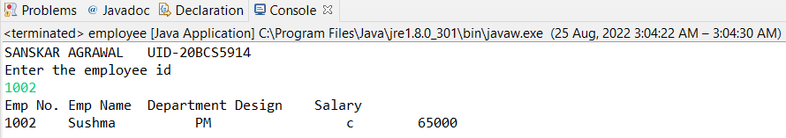

**Learning Outcomes(What I have learnt):-**

1. To create a program using array in Java.
2. To generate analytical and conceptual ability related to fundaments of Java.

**Evaluation Grid (To be created as per the SOP and Assessment guidelines by the faculty):**

|  |  |  |  |
| --- | --- | --- | --- |
| Sr. No. | Parameters | Marks Obtained | Maximum Marks |
| 1. |  |  |  |
| 2. |  |  |  |
| 3. |  |  |  |
|  |  |  |  |